Chapter 6, Solution 77.

i = i_{R} + i_{C}

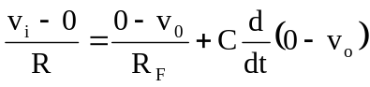
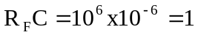

Hence 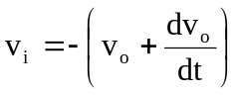

Thus v_{i} is obtained from v_{o} as shown below:
t (s)
3
2
0
4
1
–dv_{o}(t)/dt
-4
4
3
2
0
4
1
– v_{o}(t) (V)
t (s)
-4
4

3
2
8
1
v_{i}(t) (V)
t (s)
-8
4
-4

